Ruit 139 – Gebruik die 1983-vertaling
Naam:
Gemeente:
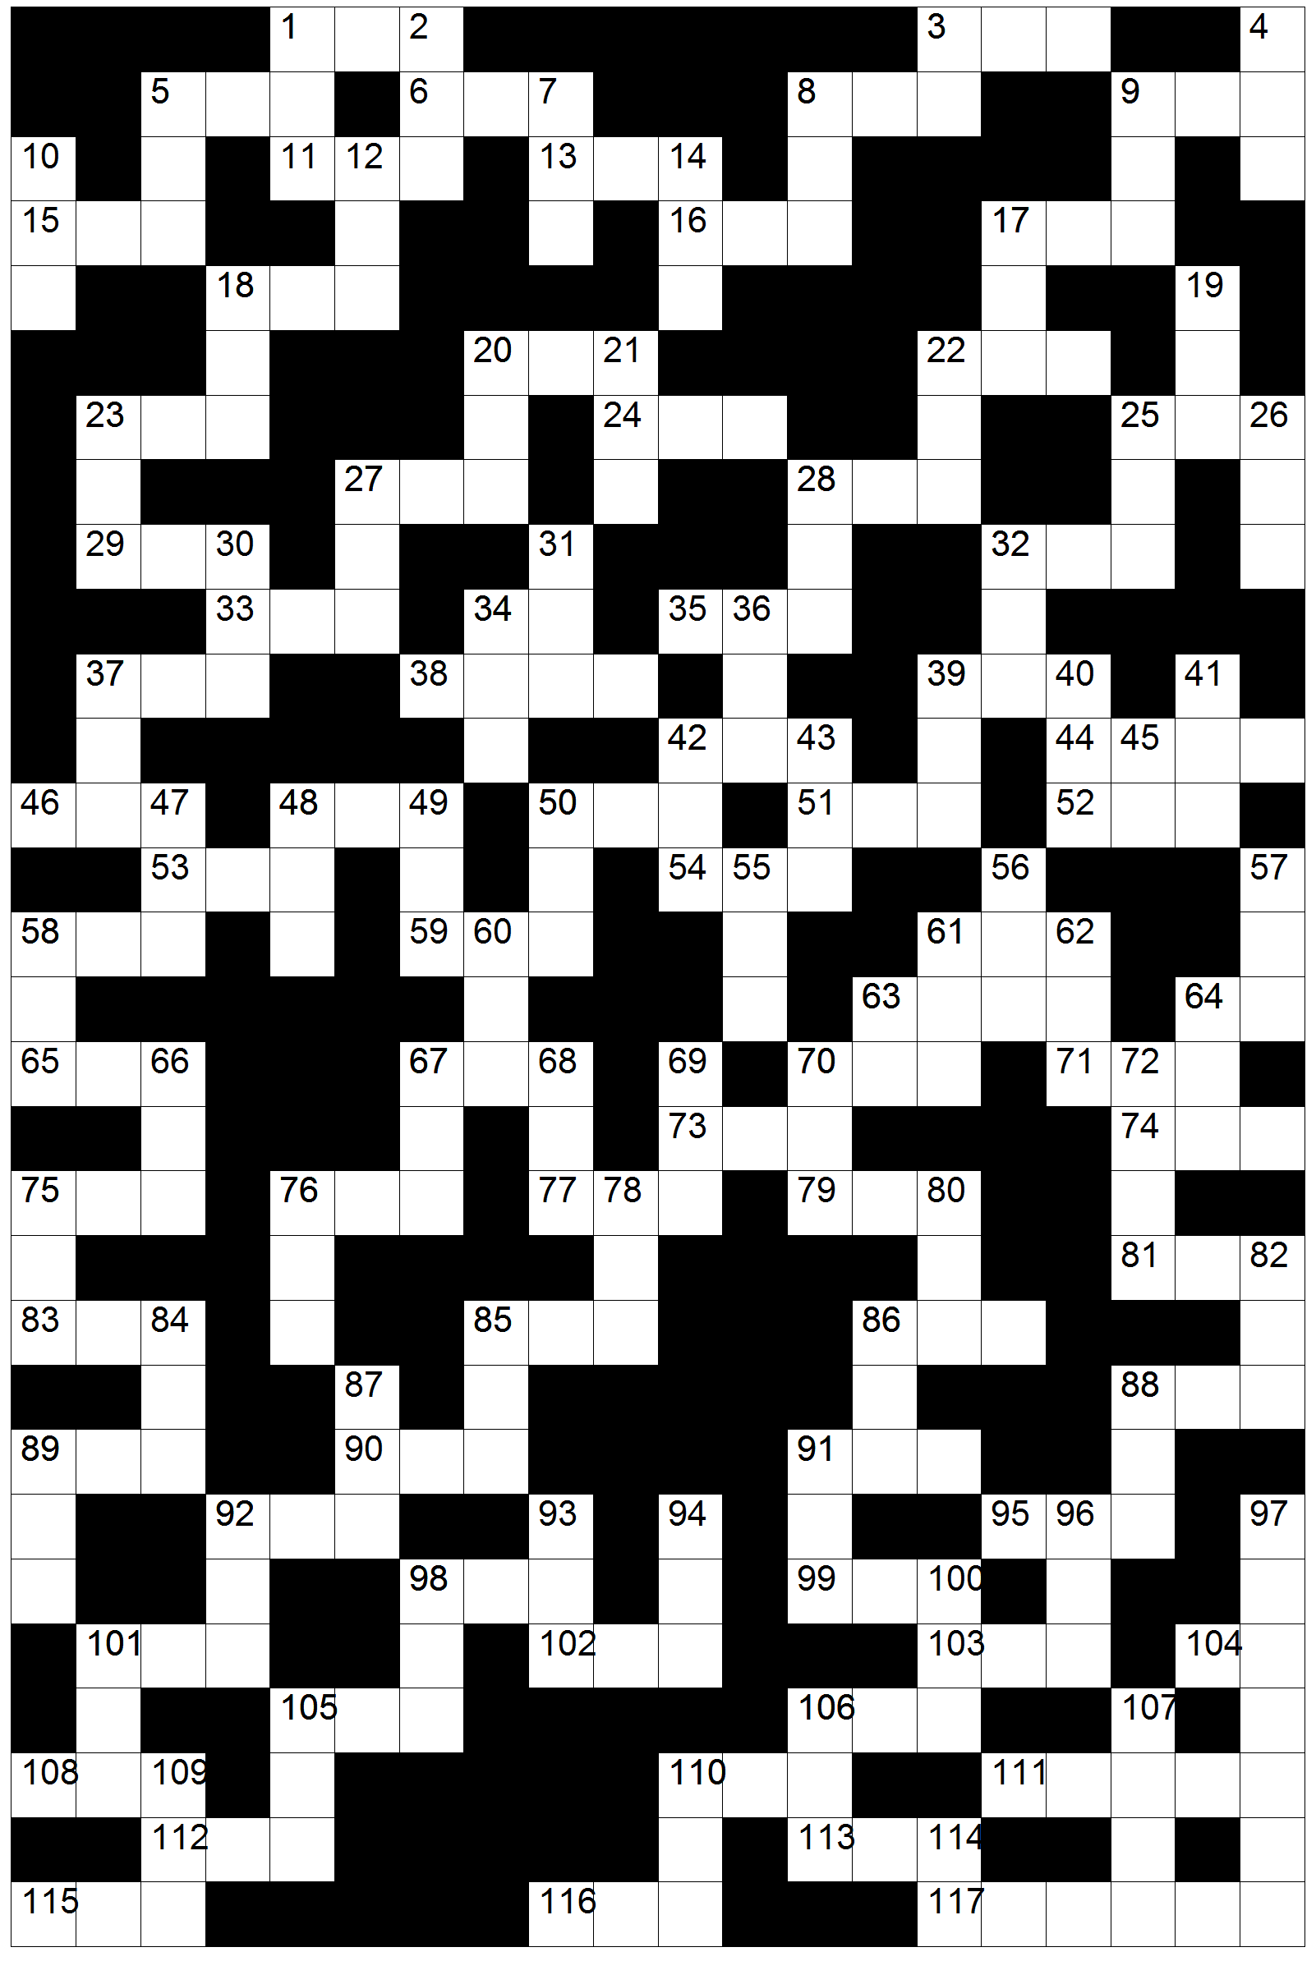

Leidrade en antwoordblad
(Wenk: begin by 16 Dwars en 28 Af)

Af
1 1 Petrus 3:21
2 Miga 4:10
3 Filemon 1:19
4 Jeremia 23:16
5 Psalm 63:1
7 Handelinge 27:17
8 1 Korintiërs 12:24
9 Lukas 8:27
10 Sefanja 3:3
12 Maleagi 1:14
14 1 Kronieke 2:32
17 Kolossense 3:11
18 1 Samuel 7:12
19 Rigters 6:26
20 1 Samuel 9:26
21 Hosea 7:16
22 Hebreërs 12:5
23 Jeremia 46:22
25 Judas 1:23
26 Jeremia 11:19
27 Rigters 8:3
28 Josua 19:35
30 Job 21:33
31 Lukas 11:11
32 1 Konings 1:8
34 Judas 1:25
36 1 Kronieke 8:12
37 2 Samuel 8:10
39 Openbaring 6:8
40 Maleagi 4:1
41 Lukas 13:34
42 Efesiërs 5:14
43 Filippense 3:13
45 3 Johannes 1:14
47 Prediker 9:2
48 Job 31:14
49 Psalm 25:19
50 2 Korintiërs 9:3
55 1 Konings 10:22
56 2 Tessalonisense 2:13
57 Psalm 91:12
58 Openbaring 20:8
60 Jeremia 41:9
61 Deuteronomium 28:35
62 Sagaria 1:8
63 Numeri 16:3
64 1 Konings 2:32
66 Jona 4:11
67 Levitikus 24:5
68 2 Konings 2:17
69 Josua 13:21
70 1 Samuel 19:13
72 Ester 9:18
75 Jesaja 27:3
76 2 Konings 2:24
78 Habakuk 3:16
80 Klaagliedere 3:19
82 Jeremia 22:10
84 Hebreërs 7:1
85 Amos 4:8
86 Jeremia 31:39
87 Rut 2:15
88 1 Samuel 13:2
89 Filemon 1:8
91 Jakobus 5:11
92 Jesaja 66:19
93 Romeine 11:24
94 1 Tessalonisense 3:5
96 Habakuk 3:6
97 Markus 14:21
98 Esra 7:24
100 Genesis 6:16
101 Psalm 42:11
105 Hosea 10:11
106 Esegiël 15:3
107 Jakobus 4:4
109 Eksodus 21:6
110 Psalm 50:19
114 Jeremia 46:25

Dwars
1 Numeri 16:38
3 Joël 2:8
5 Miga 5:6
6 2 Timoteus 2:6
8 Johannes 8:6
9 Jeremia 18:15
11 1 Kronieke 4:15
13 Genesis 36:12
15 Markus 4:28
16 Esegiël 48:27
17 2 Timoteus 1:7
18 Lukas 3:36
20 2 Kronieke 33:14
22 Titus 1:3
23 2 Korintiërs 12:1
24 Eksodus 29:9
25 1 Johannes 3:19
27 Johannes 20:5
28 Handelinge 21:3
29 Kolossense 4:10
32 Klaagliedere 2:16
33 Esra 2:57
34 Deuteronomium 2:29
35 Nahum 3:3
37 Johannes 5:11
38 Hooglied 4:14
39 Amos 9:3
42 Spreuke 6:29
44 2 Petrus 3:18
46 Numeri 11:5
48 Matteus 28:16
50 Galasiërs 6:1
51 Sagaria 14:4
52 Daniël 2:35
53 Genesis 46:21
54 2 Samuel 12:4
58 Obadja 1:1
59 2 Samuel 3:8
61 Nehemia 3:16
63 2 Kronieke 27:5
64 2 Johannes 1:10
65 Genesis 43:11
67 2 Samuel 11:2
70 Josua 24:12
71 Haggai 2:12
73 Esegiël 42:3
74 Esegiël 26:20
75 Obadja 1:5
76 Levitikus 16:10
77 Matteus 27:46
79 Rut 2:19
81 1 Kronieke 9:36
83 Eksodus 36:24
85 Rigters 3:22
86 Hooglied 7:9
88 Genesis 11:19
89 1 Petrus 3:21
90 1 Timoteus 5:11
91 Miga 7:2
92 Eksodus 1:15
95 Efesiërs 6:13
98 Ester 3:9
99 3 Johannes 1:10
101 Handelinge 12:7
102 Jesaja 59:10
103 Romeine 11:8
104 Spreuke 19:26
105 Jeremia 51:7
106 Sefanja 1:17
108 Numeri 33:55
110 Jesaja 28:7
111 Esegiël 48:13
112 Prediker 10:18
113 Nehemia 8:17
115 Handelinge 13:21
116 Joël 2:5
117 Genesis 19:31

