Ruit 140 – 1933/53 vertaling
Naam:
Gemeente:
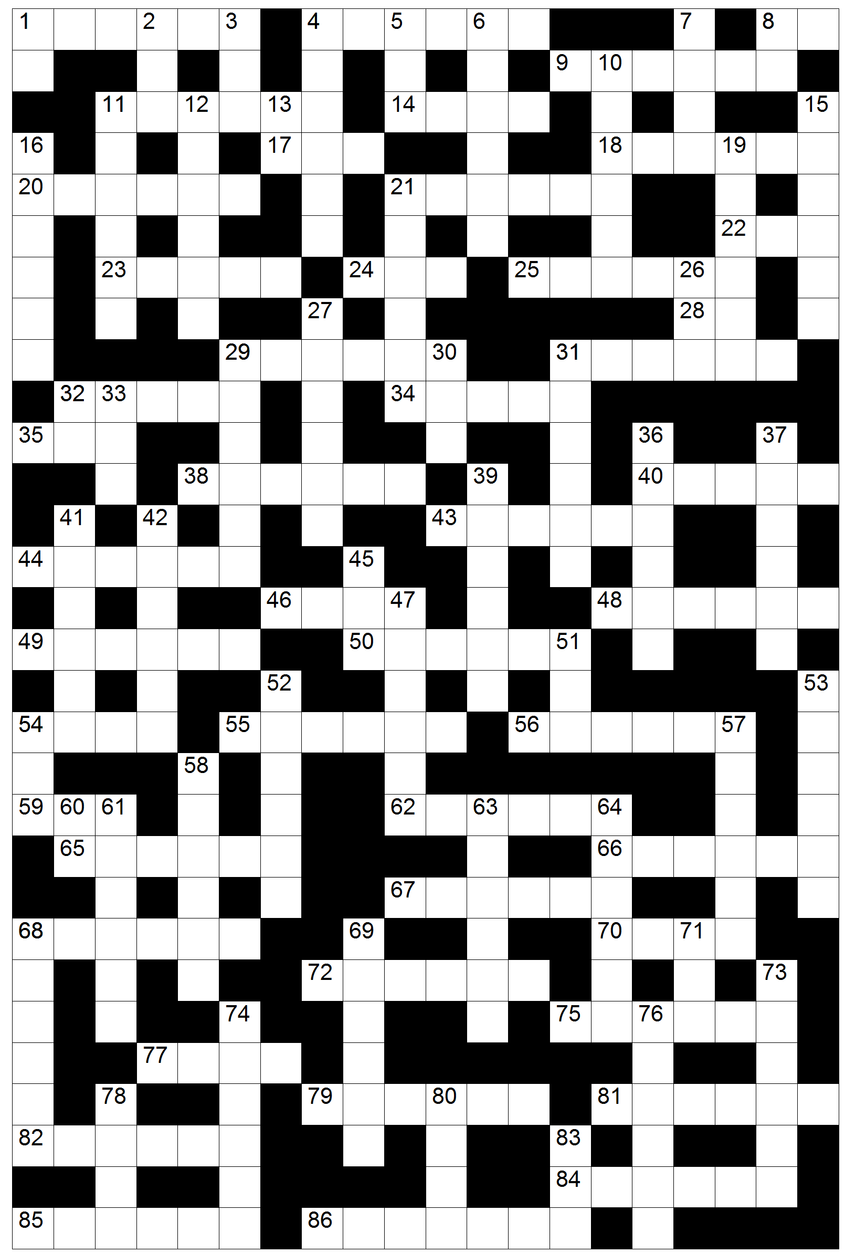

Leidrade en Antwoordblad

Af
1 Miga 1:13
2 Habakuk 1:5
3 Rut 4:11
4 Ester 8:3
5 Numeri 28:19
6 Genesis 30:16
7 Titus 1:5
8 2 Petrus 1:13
10 Esegiël 47:10
11 Jeremia 51:27
12 Matteus 11:5
13 Filemon 1:5
15 2 Samuel 3:4
16 Openbaring 8:13
19 Rigters 3:23
21 Handelinge 13:8
26 3 Johannes 1:10
27 Eksodus 3:18
30 Spreuke 23:2
31 Judas 1:24
32 Efesiërs 1:21
33 2 Timoteus 2:15
36 1 Samuel 14:24
37 Deuteronomium 5:21
39 1 Tessalonisense 2:15
41 2 Konings 20:11
42 Josua 19:9
45 Maleagi 2:12
47 Markus 9:42
51 Prediker 9:2
52 2 Korintiërs 8:19
53 1 Kronieke 1:21
54 Jesaja 14:19
57 Job 39:23
58 2 Tessalonisense 2:4
60 Filippense 3:8
61 Sagaria 13:5
63 2 Kronieke 28:12
64 Sefanja 1:8
68 Eksodus 15:1
69 1 Kronieke 23:9
71 Lukas 20:35
73 Rigters 14:19
74 1 Kronieke 11:27
76 Matteus 5:45
78 1 Kronieke 2:27
80 Hooglied 2:3
83 2 Kronieke 17:2

Dwars
1 1 Johannes 2:11
4 Handelinge 25:11
8 Obadja 1:16
9 Handelinge 25:23
11 Jona 1:12
14 Handelinge 28:23
17 Openbaring 21:9
18 Deuteronomium 10:7
20 Job 30:14
21 Hebreërs 11:27
22 Numeri 34:10
23 Nehemia 13:15
24 2 Johannes 1:12
25 Job 30:2
28 Numeri 21:28
29 1 Kronieke 11:46
31 1 Samuel 14:17
32 1 Johannes 3:12
34 Johannes 4:6
35 Ester 9:1
38 2 Petrus 1:16
40 Matteus 1:15
43 Jesaja 25:5
44 Psalm 119:11
46 Levitikus 17:5
48 Hebreërs 5:12
49 Haggai 1:9
50 Nahum 1:14
54 Joël 2:28
55 Prediker 2:26
56 1 Timoteus 5:14
59 Markus 13:28
62 1 Petrus 3:5
65 Hosea 7:4
66 Nehemia 7:7
67 Esra 10:43
68 Klaagliedere 4:7
70 Kolossense 2:14
72 2 Konings 22:14
75 Galasiers 2:14
77 Amos 6:12
79 Esegiël 27:18
81 Daniël 11:39
82 Romeine 2:4
84 1 Korintiërs 9:15
85 1 Konings 17:10
86 Romeine 9:10

